**Collection Framework-**

Why it is called as framework because it contain the collection of classes and interface that work together.

Need of collection?

1. Array are fixed in size, once it is created we cannot change its size based on requirements.
2. Array can hold homogenous data elements.
3. There is no readymade method support available in array.

To overcome this problem, we should go for collection.

1. Collections are growable in nature, based on our requirement we can increase or decrease the size.
2. Collection can hold homogenous and heterogeneous elements.
3. Every collection class is implemented based on some data structure.
4. Hence readymade method support is available.

Difference between Array and Collection.

|  |  |
| --- | --- |
| Array | Collection |
| Fixed in size | Growable in nature |
| It hold homogenous data only. | It hold homogenous and heterogeneous type of data. |
| Readymade method support is not available | Readymade method support is available. |
| Array can hold both primitives data types and objects | It hold only objects not primitives data type. |
|  |  |

**Collection (I)-**

If we want to represent the group of objects as single entity then we should go for collection.

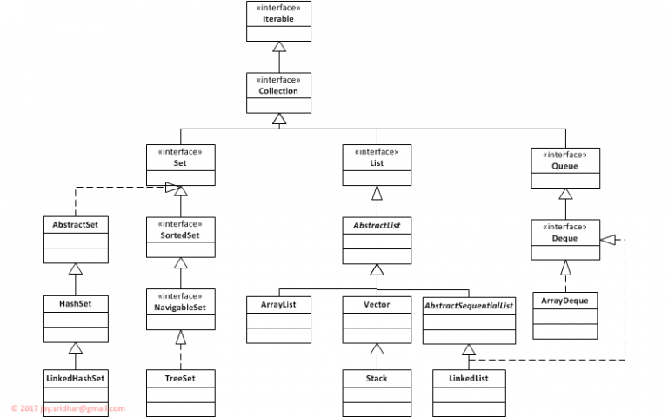

Collection Framework-

It defines several classes and interface which can be used as objects as single entity.

There are 9 key interfaces of collection framework.

1. Collection
2. List
3. Set
4. SortedSet
5. NavigableSet
6. Queue
7. Map
8. SortedMap
9. NavigableMap
10. Collection-
11. If we want to represent group of individual objects as single entity then we should go for collection.
12. Collection interface defines the most common method which are applicable for any collection objects.
13. In general, Collection interface is considered as root interface of collection framework.

Note- There is no concreate class which implements collection interface directly.

**List**

1. It is child interface of collection.
2. It is present in Java.util.Package.
3. If we want to represent group of individual objects as single entity where duplicates are allowed and insertion order is preserved then we should go for list.
4. We can differentiates by using index.
5. We can preserve insertion order by using index. Hence index plays important role. It will get the same sequence of element while retrieving the elements.
6. It has three subclasses in java such as- ArrayList LinkedList Vector, etc.
7. **ArrayList**
8. The ArrayList extends the AbstractList and implements the List interface.
9. Duplicates are allowed.
10. Insertion order is preserved.
11. Heterogenous objects are allowed.
12. Null insertion is possible.(we can add n number of null values in arraylist.

Constructor-

There are four types of constructor as below.

1. ArrayList al= new ArrayList();

Create the empty array list with default initial capacity 10. Once array list reaches its max capacity then new array list will be created with its new capacity.

1. ArrayList al= new ArrayList(int initial_capacity);

Here we are passing the int type value.

1. ArrayList al= new ArrayList( Collection c);

Here we are passing the objects.

Example-

**import** java.util.ArrayList;

**public** **class** ArrayListDemo {

**public** **static** **void** main(String[] args) {

ArrayList al= **new** ArrayList();

al.add(50);

al.add("ram");

al.add(10);

al.add(**null**);

System.***out***.println(al);

}

}

Output-

[50, ram, 10, null]

Note-

1. ArrayList is the best choice if our frequent operation is retrival operation.

It implements the random access interface.

1. ArrayList is the worst choice if our frequent operation is insertion or deletion (because several shift operation are required for this).

How to get the synchronized version of ArrayList ?

By default, all the methods in array list are non-synchronized but we can get the synchronized version of arraylist by using collection class synchronized list method.

Example – ArrayList al= new ArrayList(); //this is non-synchronized

List list=Collections.synchronizedList(al); // this is synchronized